**TABLEAU**

# NOTE

* **AGGREGATION - Top, Bottom, Non-Null**
* **ANALYSIS – Highlighter**
* **ANALYTICS PANE - Custom | Model - Lines – Drag to View -SELECT CORRECT OPTION**
* **AXIS – Double Click – Format**
* **AXIS - Edit X Y Axes**
* **AXIS – Right Click – Hide Field Labels**
* **AXIS - X | Y Labels | Marks cards | Filters | Special - DO NOT MATCH ALWAYS AUTOMATICALLY**
* **CALCULATED FIELD - Drop down carat - Top of Data Pane**
* **CALCULATED FIELD - Right Click measure – Create Calculated Field**
* **CALCULATED FILED – DATEPART - SUNDAY = 1 SATURDAY = 7**
* **DASHBOARD - Right Click – Use as Filter**
* **DASHBOARD – Right Click Visual – Filters – Choose Filters**
* **DASHBOARD – Utilize Top Left for important KPIs**
* **DATA - Convert between dimensions and measures / discrete and continuous**
* **DATA - discrete dimensions and continuous measures are most common combinations of data roles**
* **DATA - Measure Names | Measure Values ARE AUTOMATICALLY GENERATED ALL FIELDS ABOVE**
* **DATA - Tableau assigns data roles to fields automatically. Good practice to review and adapt**
* **FILETR - Measure Names | Measure Values TO ADD MORE FILEDS (INCLUDING CALCULATED)**
* **FILTER – Customize – Show Apply Button**
* **FILTER - Drag to Filter Card or Filter Directly (gets added to Filter card)**
* **FILTER - Fields in Marks Cards can be used as conditions for Filters – BUT CHECK**
* **FILTER – More than one filter – Right Click – Show Relevant Values**
* **FILTER - Order - Extract | Data source | Context | Dimension | Measure**
* **FILTER – Right Click Measure or Dimension – Show Filter**
* **FILTER – Single Value Dropdown**
* **MARKS - Adding to Marks Cards adds to Row or Column**
* **MARKS - Cards – Edit type – Separate for each measure**
* **MARKS – Change chart type in dropdown**
* **MARKS – Edit Label | Change Format | Alignment**
* **MARKS - Show Mark Labels button**
* **MARKS - Drag order for Treemaps**
* **QUICK TABLE CALCULATIONS - Triangle**
* **TABLE The field that is listed first in the rows shelf will appear first**
* **VISUAL - Can Drag directly to View**
* **DATA – Create Bins**
* **VISUAL – Exclude Null**
* **VISUAL – Lasso Select – Drag to Bottom**
* **VISUAL – Right Click value – Edit Alias**
* **VISUAL - Show Me button – Ctrl + 1**
* **VISUAL – Tableau will not show if too crowded**
* **WORKSHEET – Right Click – Duplicate as Crosstab**
* **FILTER – Exclude Null**
* **TOOLTIPS - Edit format**
* **TOOLTIPS - Add Visualization**
* **VISUALIZATION - Drag pills to the chart area for quick colour**
* **DATA - Use CTRL key to multi-select pills to drag on and off the canvas**
* **DATA - CTRL + F - Search field name**
* **DATA - Type field names on inline formula**
* **DATA - Right-click (OPTION) and drag a field to Rows, Columns, or the Marks card**
* **DATA - CTRL (CMD) -drag to quickly duplicate fields**
* **DATA - Hide fields not being used/show hidden fields - Data Pane - Dropdown carat**
* **DATA - Create fast hierarchy - Drag one pill on top of another pill - drag other pills – rename Hierarchy**
* **DATA – Drill down Hierarchy – Click + Plus icon**
* **VISUALIZATION - Drag x or y axis to chart area for colour**
* **KPIs - Right Click Measure values and add to sheet**
* **DATA – Sort**
* **FILTER – Apply to Selected Worksheets**
* **DASHBOARD – Keep track of filters and which visualizations they impact**
* **DATA – Type of Data shows before value**
* **DATA – Link icon to link 2 or more datasets**
* **MARKS – Change Label colour to match – Match Mark Color**
* **DATA – Group by Folder**
* **VISUAL – Multiple pills in Columns for side-by-side (Compute using Pane across)**
* **REFERENCE LINE – Analytics Tab – Label Value**
* **MARKS – Colour – Right Click Dimension – Show Highlighter**
* **DATA – Dimensions with more values in Columns (X) – Dimensions with fewer values in Rows (Y)**
* **DATA – Column Chart – Measure (green) in Rows – Dimensions (blue) in Columns**
* **DATA – Try moving pills behind and in front of each other and from and between rows and columns**
* **TOOLTIP – Preview**
* **TOOLTIP – Add Filter – Add to Context**
* **MARKS – Colour – Advanced – Set Start and End**
* **MAPS – Mixed – Drag 2nd geometry parameter to canvas – Add Marks card Layer**
* **Maps – Mixed – Drag marks card to bring to front and back**
* **MAPS – Style**
* **DATA - Data Source Locale**
* **DATA - Workbook Locale**
* **ROWS - Type it in**
* **Save ad-hoc or Quick Table Calculation into Data Pane – Right Click or drag itt from Canvas into Data Pane – give it a name**
* **DATA – Add header of categorical variable to Table – Drag measure values to column (double click) – can sort counts**
* **DATA – Summary Card – Right click to add more summary values**
* **DATA - Create Matrix – Drag same values to Rows and Columns – Disaggregate**
* **DATA - Table - Drag pill to Columns - Double click pills**

# Create and format visualizations

* Drag and drop dimensions and measures on the canvas, shelves and cards.
* Canvas - where your visualizations will appear.
* Columns - correspond to the x axis of your view.
* Rows - correspond to the y axis.
* Pages shelf lets you break a visualization into several pages, e.g. one page for each neighbourhood.
* Filters shelf lets you filter your data, and you will learn more about this in a next chapter.
* Marks field contains marks cards and marks types.
* Marks cards encompass color, size, and shape: these let you add context and detail to your view.
* Marks types - You can change the type of marks displayed in the view to fit your analysis better.
* Informative titles
* Colours and large fonts
* Legends
* Adjust axes and titles
* Create tooltips
* Can format at both Workbook and Sheet level
* **Dual Axes – Drag to top and right | Right click and choose Dual Axes**
* **Right Click on Y Axis – Choose Synchronise Axes**
* **Hide axes**
* **Centre title**
* **Edit Axes names**
* **Add colours to dimension**

# Workbook vs Sheet

|  |  |
| --- | --- |
| **WORKBOOK** | **SHEET** |
| .twbx | Similar to Excel tab |
| Organise, save share and publish | Displayed along workbook bottom |
| Multiple sheets | 1. Worksheet |
| Similar to whole Excel file | 1. Dashboard |
|  | 1. Story |

# Dashboard vs Story

|  |  |
| --- | --- |
| **DASHBOARD** | **STORY** |
| **Worksheet can be placed in a Dashboard** | **Dashboard can be placed in a Story** |
| Collection of several views | Dashboards can be bookmarked to create stories |
| Easy to compare data | Sequence of visualizations to tell a narrative |
| Uncovers key insights | Each individual visualization is called a Story Point |
| Automatically connected to worksheets | 1. Dashboard |
| Drill down and do advanced | 1. Story |
| Views can be connected – 1 view is interactive filter |  |

* Drag different Worksheets to Dashboards overlay
* Can move | float legend and filters
* Use visualisations | dashboards as interactive filters
* **Add Filter - Click visualisation | dashboard – Analysis toolbar – Filters**
* Drag different Dashboards to Story

# Discrete

* Blue fields are discrete, or categorical fields, they have individually separate and distinct values.
* Examples include room type, neighbourhood, and the ID number of the listing.
* **Discrete means "individually separate and distinct."**

# Continuous

* Green fields are continuous fields, treated as an infinite range.
* Examples are the number of reviews per month, room price, or the longitude of the location.
* **Continuous means "forming an unbroken whole, without interruption".**

# Dimensions

* Colour coded Blue
* Dimensions, positioned at the top, contain qualitative values, such as names or dates.
* E.g. in dataset: Neighbourhood, Room Type, or number of reviews per month.

# Measures

* Colour Coded Green
* Measures, positioned under the dimensions, contain numeric quantitative values that you can measure, and aggregate.
* E.g. in dataset: Price, Number of minimum nights, and Total number of reviews.

# Dimensions / Measures / Discrete / Continous

* Measures - usually metrics, or numerical data
* Measures are aggregations – up to the granularity set by the dimensions in the view
* Measure value depends on the context of the dimensions
* Dimensions are usually categorical fields - set the granularity, or LOD in the view
* Dimensions used to build the view will determine # of marks
* Continuous numbers can take on any value in a range
* Discrete numbers have distinct, separate values
* **Dimensions are Discrete in Blue -** come out onto the view as themselves
* **Measures are Continuous in Green -** come out onto the view as aggregates
* Continuous pill creates an axis - automatically fill the entire view along that direction
* Discrete pill creates a label with panes for each value - as much / little room as required
* Continuous pill on the color shelf will create a gradient
* Discrete pill on the color shelf will create a color palette
* Map - Measure on color defaults to a filled map
* Map - Dimension on color defaults to a symbol map
* Map - gradients or palettes depends on if the pill is continuous or discrete
* Dates - options at the top are Discrete date parts - are treated like categories
* Dates – options at bottom are Continuous date truncations - treated as an ongoing progression along an axis
* Filtering - Discrete dimension - options related to the specific list of values for that pill
* Filtering - Continuous measure - asks first if want to filter at the row-level or aggregate level - then brings up options for continuous ranges

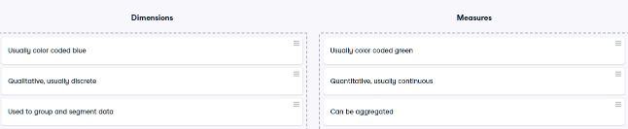

# Attribute (ATTR)

* ATTR() can indicate that there are multiple values from the secondary data source.
* Dimensions added to Tooltip on the Marks card are automatically wrapped in ATTR() because dimensions on Tooltip must be aggregated.
* ATTR() will display * as there is more than 1 value and the view or the values need to be adjusted.
* Like other aggregations, ATTR() can be used to change a non-aggregate value to an aggregate value to resolve aggregation errors in the calculation.
* When a calculation that returns numeric data contains ATTR(), if there are multiple values in the ATTR(), the calculation will return NULL rather than an asterisk.

# Data roles in Tableau

* Discrete dimensions and continuous measures are the more common combinations of data roles.
* E.g. eye color and sex, and height and weight, respectively.
* Less common E.g. discrete measures (shoe size and age) and continuous dimensions (date).

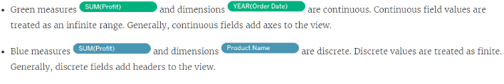

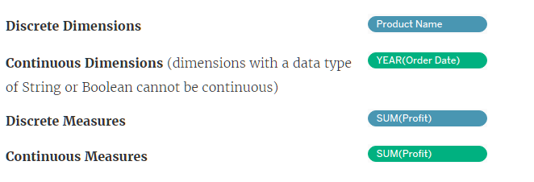

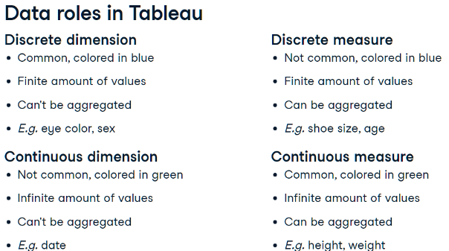

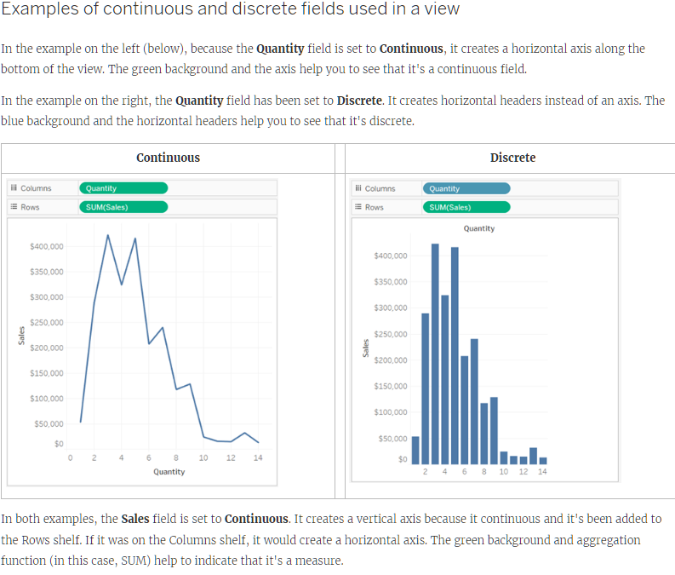

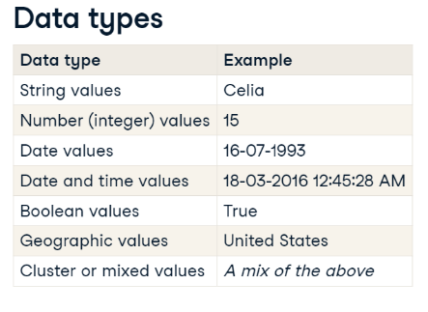

# Default properties

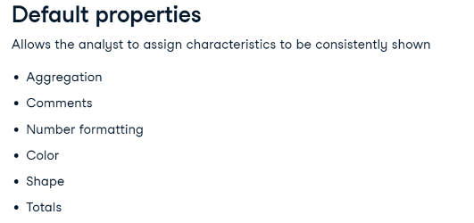

# Segmenting with dimensions

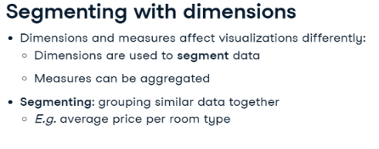

# Filters

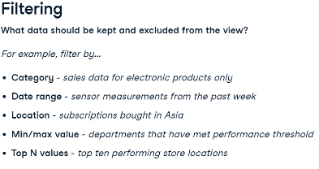

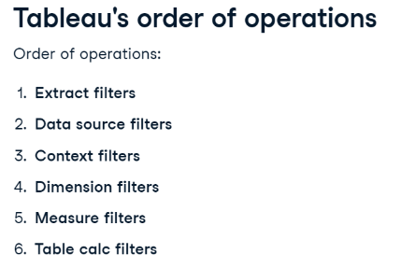

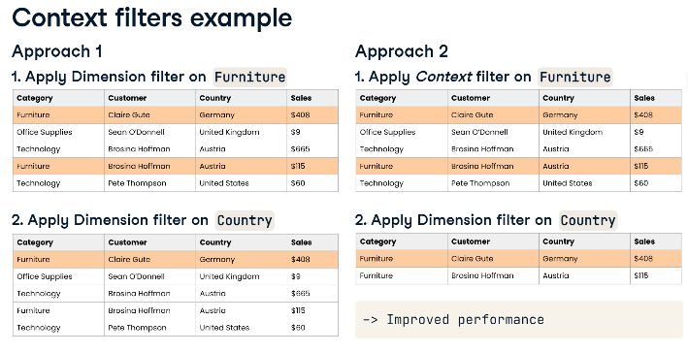

# Dimension filters (in blue)

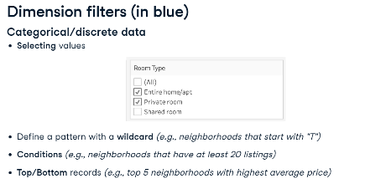

# Measure filters (in green)

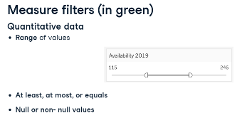

* Add Context Filter to Context – Right Click Pill in Filter shelf card - Black
* Add Segment Filter – Connect to data source

# Sorting

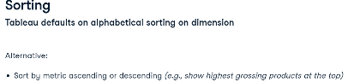

# Aggregation

* Default aggregation for Measures is SUM
* Can only aggregate Dimensions with MIN, MAX, COUNT and COUNT DISTINCT
* Aggregating a Dimension creates a temporary Measure
* All Dimension aggregations can be applied to Measures but not vice-versa

# Calculated Fields

* Create new Field - Measure or Dimension
* Analysis Tab – Create Calculated Field
* Use Functions
* Enter name of Field and add Formula
* Can be edited in dropdown
* Right click Measure and Choose Calculated Field

# Geographical Data

* Filled Map | Symbol map
* Geocoding – Globe icon
* Drag Country (globe icon) to View
  + Automatically creates map and geo data
  + Automatically adds Country to Marks Cards
* Edit Map layers in Map tab

# Date Data

* Calendar Icon
* Date hierarchy
* Top is Dimension – Discrete – Blue – Aggregates
* Bottom is Measure – Continuous – Green – Timeline
* DATEDIFF
* 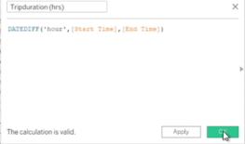
* DATEPART SUNDAY = 1 SATURDAY = 7
* 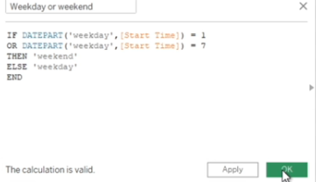

# Reference Lines, Trend Lines, Forecasting

* Reference line drawn on a chart representing another measure or point of reference E.g. AVG
* Reference line – Analytics pane - Custom
* Trend line - used to predict the continuation of a certain trend
* Trend line – Analytics pane - Model
* Forecasting - predicting the future value of a measure using mathematical models
* Forecasting – needs a time dimension and a measure
* Forecast – Analytics pane – Model

# Data Preparation

* When a numeric value is brought into Tableau, it's placed by default in the Measures section
* Move numeric fields that shouldn’t be aggregated to the Dimensions section
* Check Default Properties – Number Format - Custom
* Fit Width
* Edit Alias
* Add Highlighter - Analysis tab
* Show Filter – Customize – Show Apply Button
* Create Calculated Field – Drop Down Carat at top of Data Pane

# Discrete vs Continuous Time Analysis

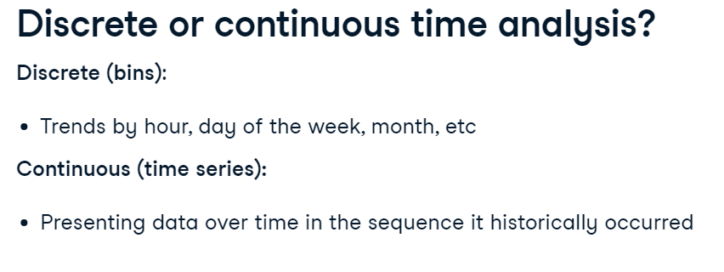

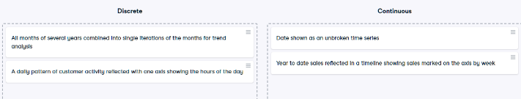

# KPI Dashboard

* Key Performance Indicators are measurable values that track a company's key business objectives.
* Turn off the field label for the columns by right clicking on it and then selecting Hide Field Labels for Column.
* Add KPI charts to pre-formatted dashboard.
* Worksheets - fit the entire view - charts will fill up whatever space is available in the dashboard.
* Turn off the title by clicking down arrow and then unchecking the title.
* When adding sheets to the dashboards, filters are automatically brought in - Remove duplicate.
* Bring in new filters - clicking the down arrow in grey menu upper right corner - Filters, select the one you want.
* Each filter drop-down - Apply to Worksheets - All Using this Data Source – when a filter is applied, every sheet using this data source will filter its content accordingly.
* Select visualization - grey menu - Select Use as Filter - Click the funnel to make it solid so it's used as a filter.

# Quick table calculations

* A table calculation is a calculation that you can apply to the values in a visualization.
* Examples include running total, difference, percent of total, and many more.
* These predefined calculations are calculated based on what is currently in the visualization.
* They do not consider any measures or dimensions that are filtered out of the view.
* Table calculations are defined by their scope and direction.
* The scope defines the group on which the calculation is performed.
* The direction defines how the table calculation moves within the scope.
* Options are across, down, down then across and so on.
* Quick table calculations are table calculations that you can apply quickly to your visualization.
* They are applied to the visualization with the most typical scope and direction settings.
* When the menu is accessed, only calculations that are possible with your data are available

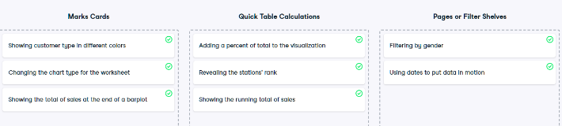

# Ranking

* QUICK TABLE CALCULATION – Rank
* TABLE CALCULTION – Edit
* Tableau applies Competition Ranking - Data with same value will get same rank

# Groups

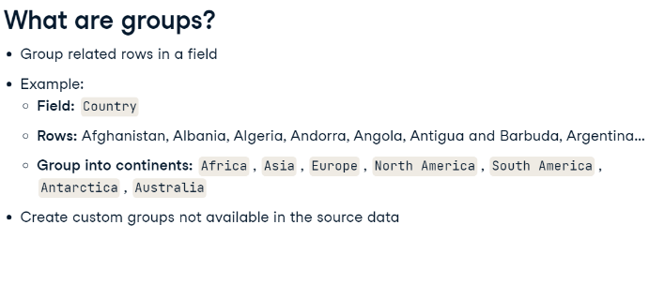

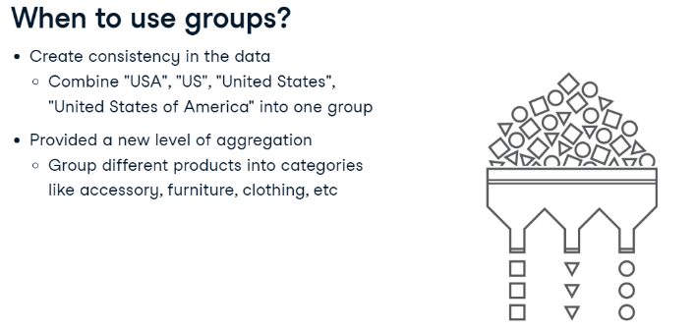

# Groups – Maps

* Lasso Selection
* Paperclip
* Edit Groups

# Parameters

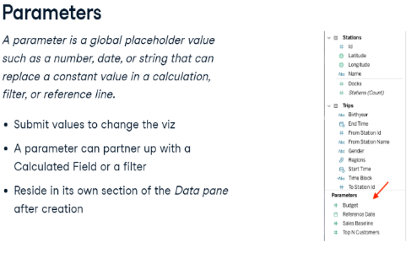

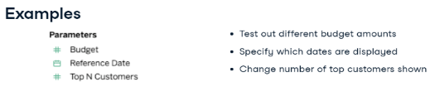

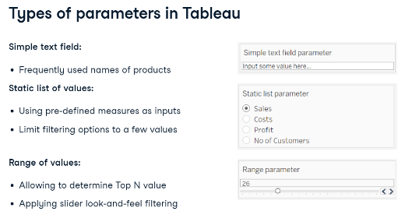

* **Create Parameter in Data Pane**
* **Set Start, End, Steps, Current Value / List / Range**
* **List – Can select Single Value List in Parameter Controls**
* **Connect to Filter -Top / Bottom / List / Condition**
* **Connect to Calculated Field – True / False check**
* **Replace pill in Visual with Parameter**
* **Show Parameter**
* **Edit Axis name with Parameter**
* **Edit Tooltip to update name**
* **Switch Parameters**

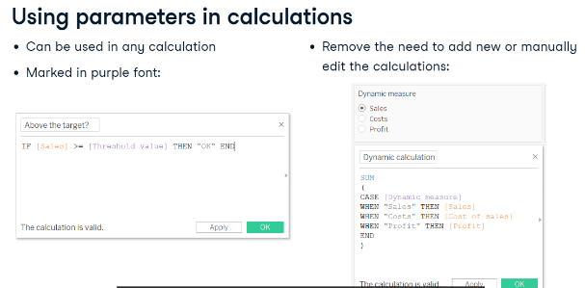

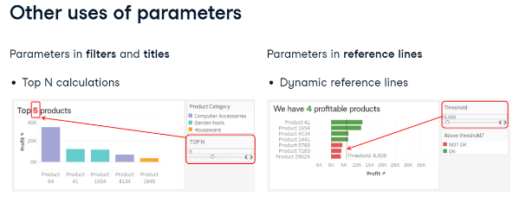

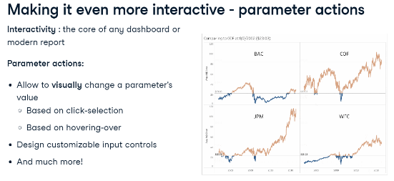

# Sets

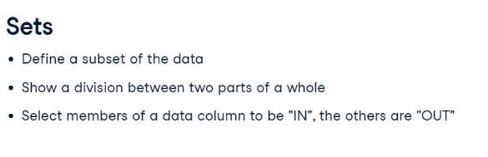

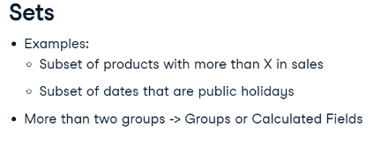

* Joined Circle
* Include / Exclude set

# Dashboards

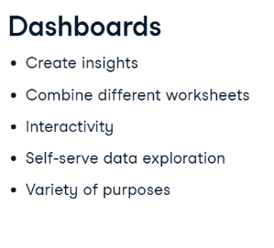

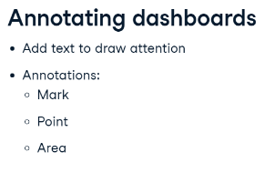

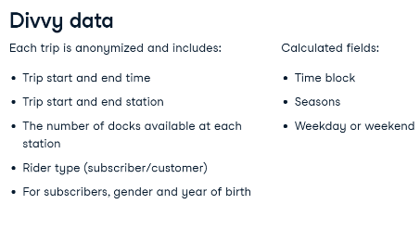

* Size - Make use of entire available space
* Worksheet - Fit - Entire View
* Edit / Hide Axis
* Use as Filter - Also filters worksheets
* VISUAL - Right Click - Annotate
* Annotation – Format
* Visualization - Show Filters (affecting the viz)
* Filter – Apply to Worksheets / All using datasource

# Dashboard Containers

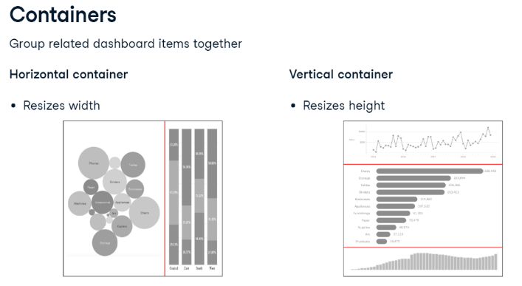

# Dashboard Actions

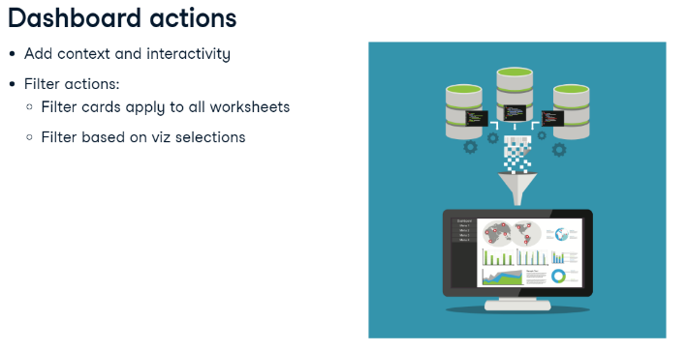

# Communicating Insights Visually

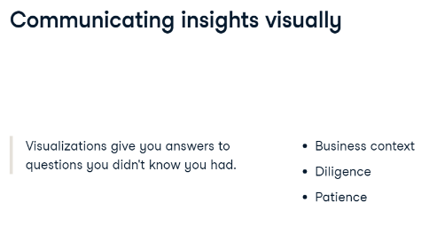

# Story Points

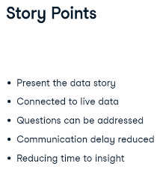

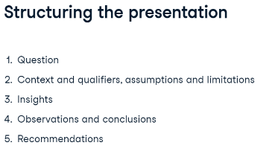

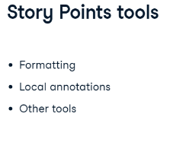

* Story – Story Points – Navigator
* Format / Edit Viz
* Annotate
* Legend – Line under Pen / Dashboard Actions
* Edit Axis – Fixed range

# Mobile

* Mobile View - Navigation - Edit

# Save / Export / Share / Extracts

* Options

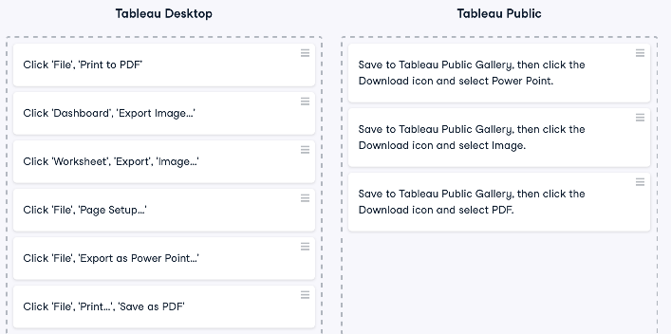

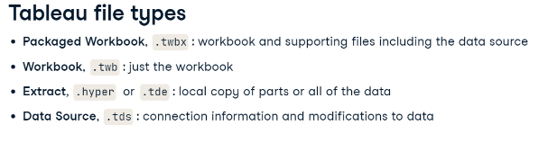

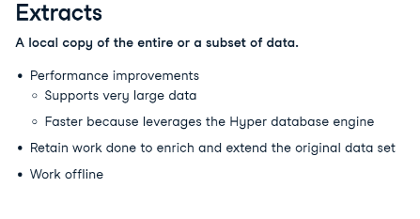

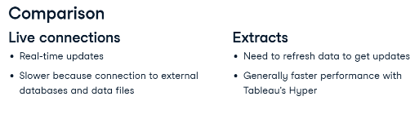

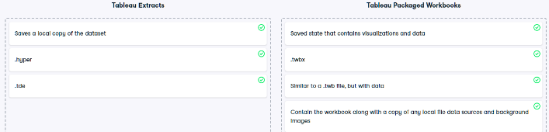

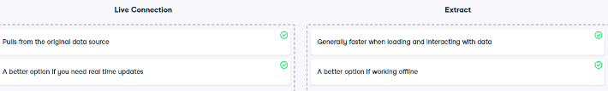

# Data Connectors

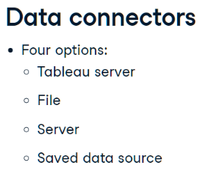

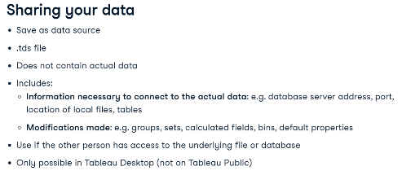

# Physical and Logical layers

* Default view in the Data Source page canvas is the logical layer of the data source
* You combine data in the logical layer using relationships (or noodles)
* Think of this layer as the relationships canvas in the Data Source page
* Next layer is the physical layer
* You combine data between tables at the physical layer using unions (and joins)
* Each logical table contains at least one physical table in this layer
* Think of the physical layer as the joins and unions canvas in the Data Source page

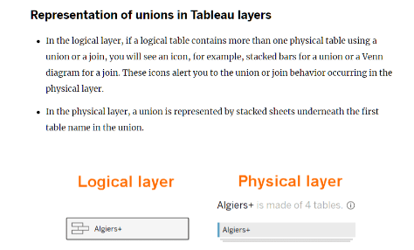

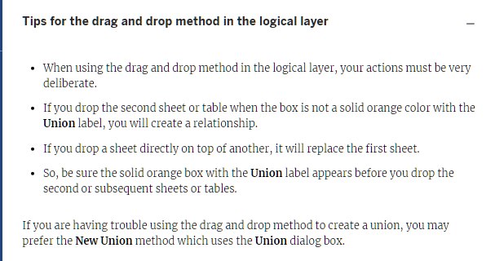

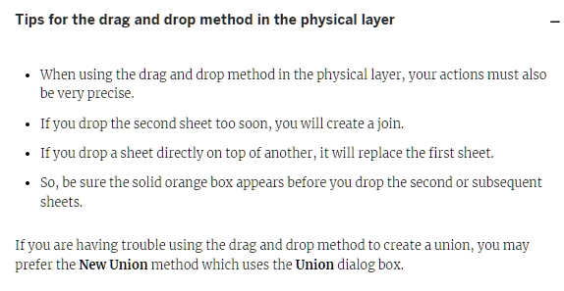

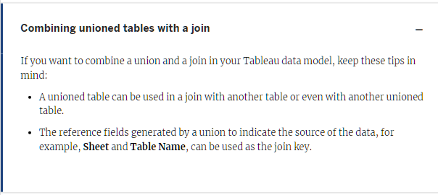

# Blends

# 

# Unions

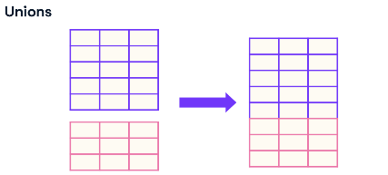

* Data Sources page
* Connect Data
* Right Click Table – Open – Drag to designated Union area
* Check Union
* Verify number of records
* Edit Union – Add / Remove

# Joins

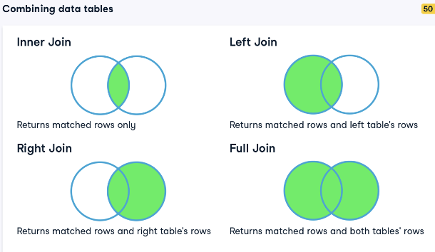

* Right Click Table – Open – Drag to Join area (outside designated Union area)
* Select Join type
* Select Join key

# Relationships

* A relationship describes how two tables relate to each other, based on common fields, but does not merge the tables together or append fields.
* When a relationship is created between tables, the tables remain separate, maintaining their individual level of detail and fields.
* One or more related fields are selected to define the relationship.
* Tableau suggests thinking of a relationship as a contract between two tables.
* Tableau will bring data from both using that contract to decide what join would be most appropriate in the given context.

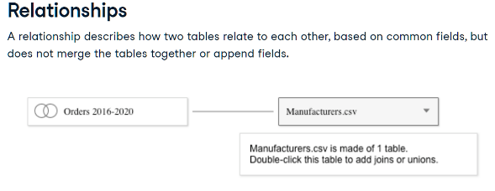

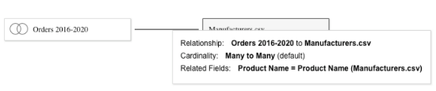

# Joins vs Relationships

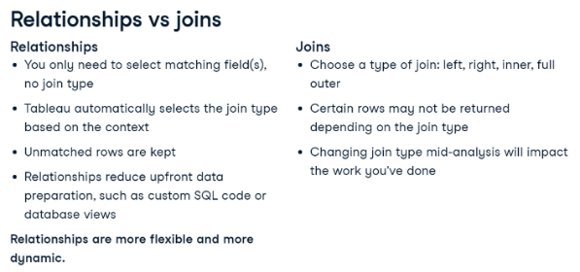

* Make connection to new Data source
* Drag to Canvas
* Edit Relationship
* Match on one or more fields

# Data Analysis Flow in Tableau

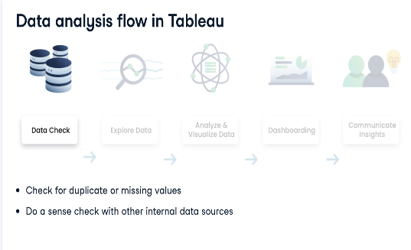

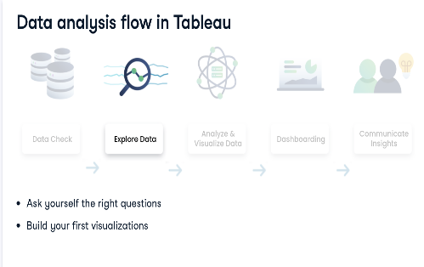

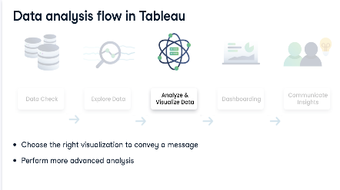

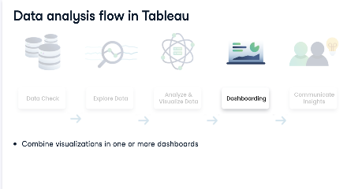

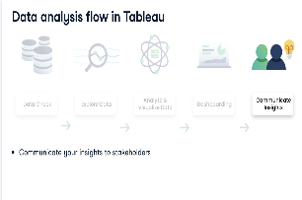

# Churn

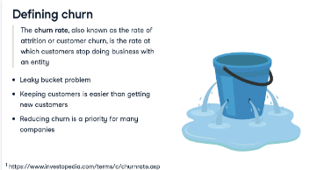

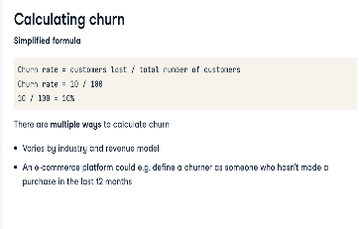

# Waterfall (bridge) chart

* Explains the net change in value between two points, split over categories
* Typically starts at a baseline of zero; then, there are a series of bars that present category contribution to the total.
* Positive values can easily be distinguished from the negative ones by the use of a categorical or graded color palette
* Exposes the complexity hidden behind an aggregated number
* Downside is that it works well with only a limited number of categories
* Running Total
* Gantt chart
* Add value to data and add negative sign
* Add grand total

# Heat map / Highlight Table

* Used for presenting density and comparisons, often in a matrix form, relying on the use of colors to communicate the values.
* Heat maps have various forms and types. The most frequently used are colored geo-maps, for example, to illustrate the density of the population, but they also are often used in web analytics to analyze where on the screen visitors click the most.
* Another use case is a matrix comparison
* Advantage of heat maps is that it gives almost an instant high-level picture through their use of easy-to-understand color gradations
* However, without appropriate labels, it might be challenging to interpret when a high level of detail is required
* Has 2 versions – Heat Maps and Highlight Table

# Scatter plot

* Show the relationship and correlation between two numerical variables plotted simultaneously along both the X and Y axis.
* Often used in exploratory data analysis or when we need to plot the data on a quadrant
* Can be multidimensional, with the use of color, size, and shape, and easily store quite some data, with a high number of data marks
* Powerful to present a correlation between two measures
* However, in many cases, scatter plots can be tricky to communicate the data insights with, especially when data marks are plentiful and when there is no immediate correlation legible from the chart.

# Pie Chart

* Proportion / Angle – Rows
* Size / Colour - Column

# Data Visualization

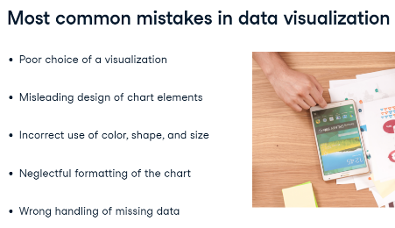

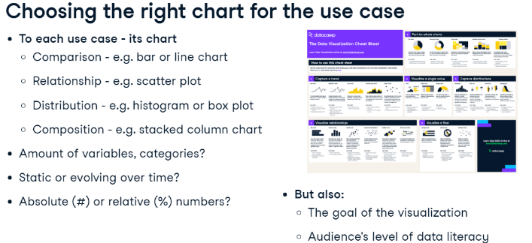

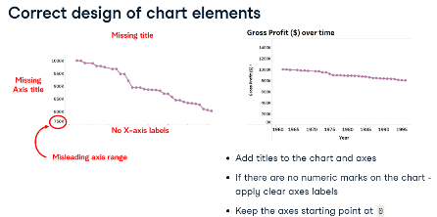

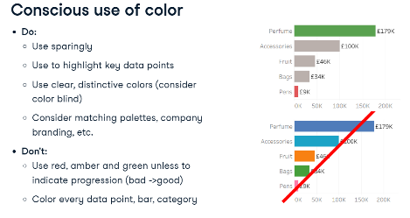

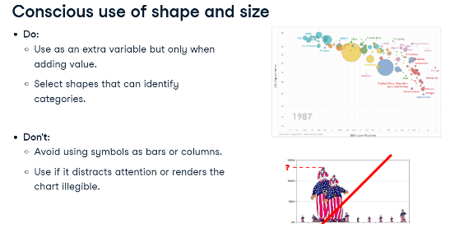

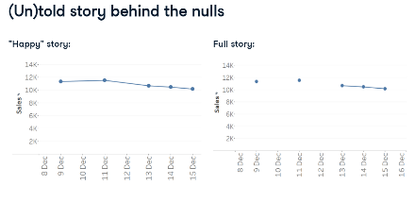

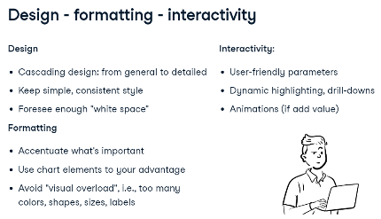

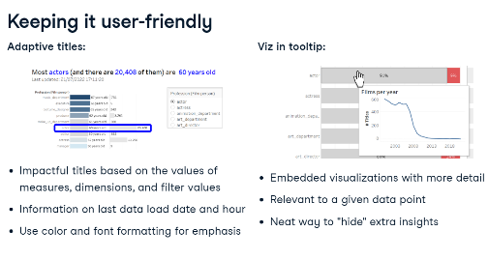

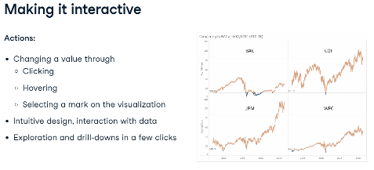

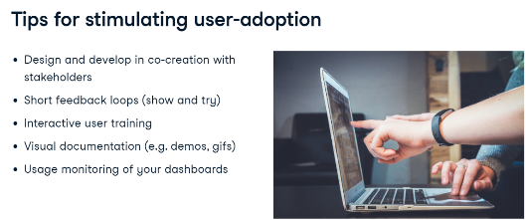

# Dashboard Actions

* Select Source and Target sheets
* Run action…
* Clearing selections will..

# Viz in Tooltips

# Connect to URL

* Calculated Filed "https://en.wikipedia.org/w/index.php?search="+[Title]
* Dashboard Webpage Object
* Action – URL

# Word / Tag cloud chart

* Key words enriched with size and / or colour
* Start with Treemap
* Convert Marks to Text

# Mapping

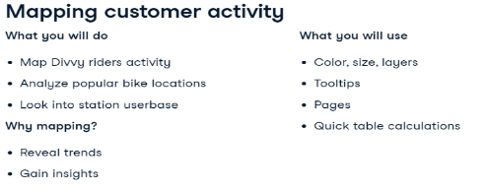

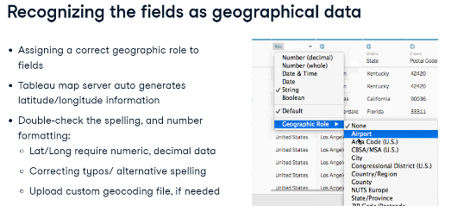

* Colour Palettes
* Opacity
* Size
* Maps – Background – Dark
* Add time filter – Add to Pages shelf
* Marks type – Density
* Density Colour
* Density Intensity
* Dual Axis
* Layering – Multiple Rows
* Multiple Marks for each map
* Overlay – Right Click Rows and select Dual Axis
* Charts on top of Maps

# Custom Maps

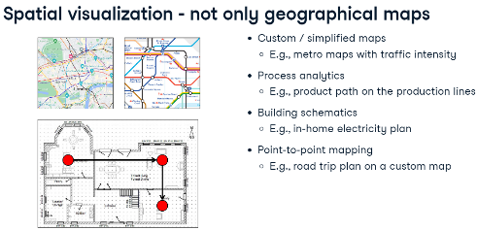

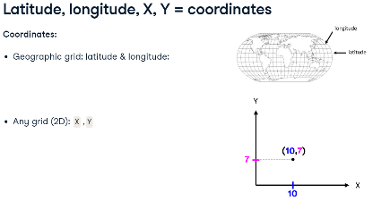

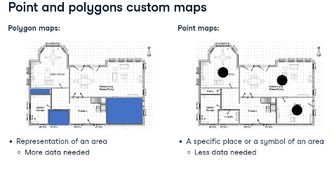

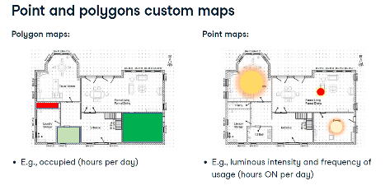

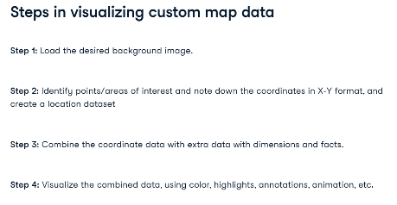

* Add custom background
* Add custom location file
* Use paths

# Advanced Charts

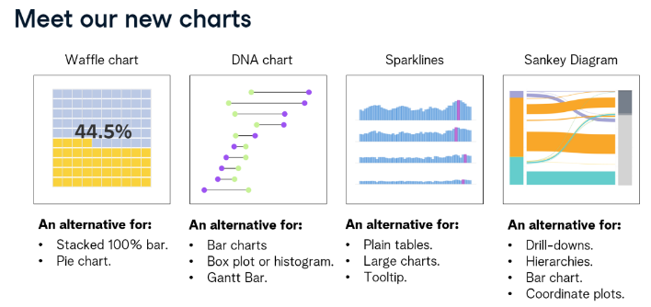

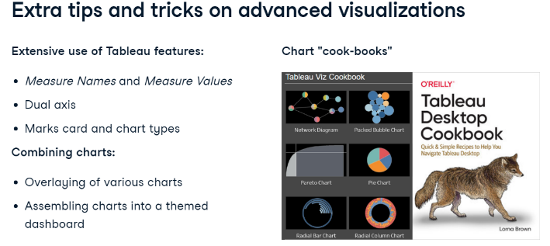

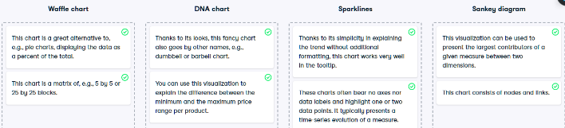

# Waffle Chart

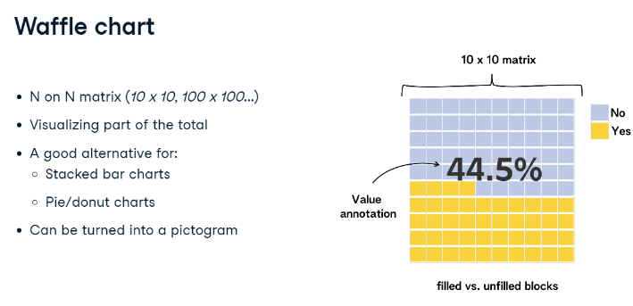

# DNA Chart

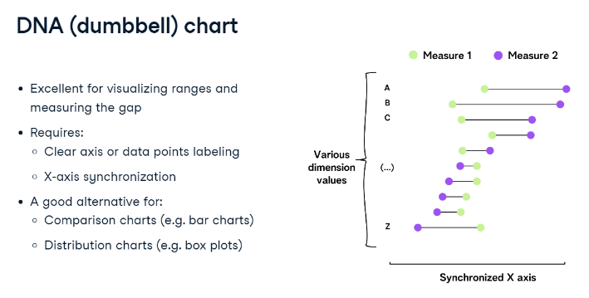

# Sparklines Chart

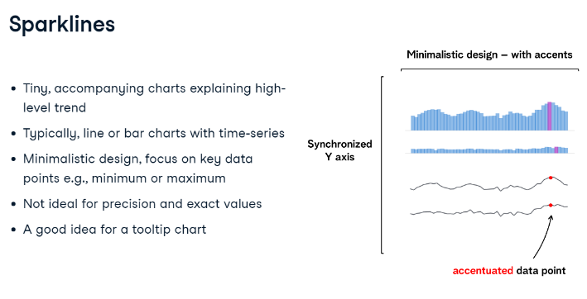

# Sankey Chart

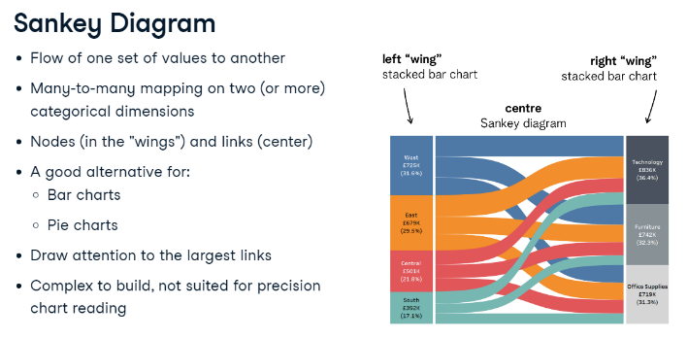

# Calculations

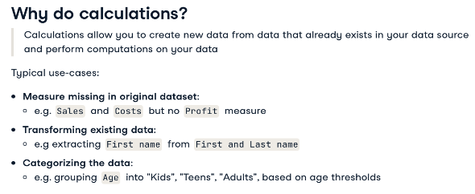

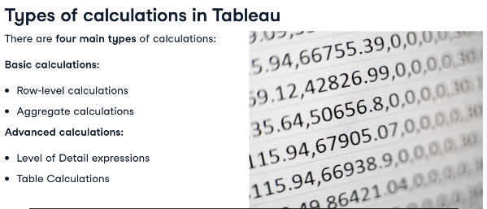

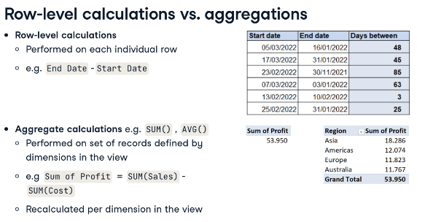

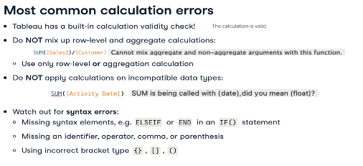

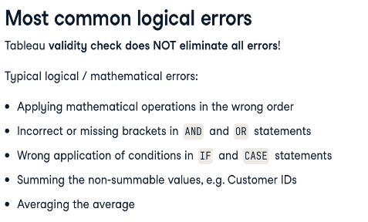

# Logical Functions

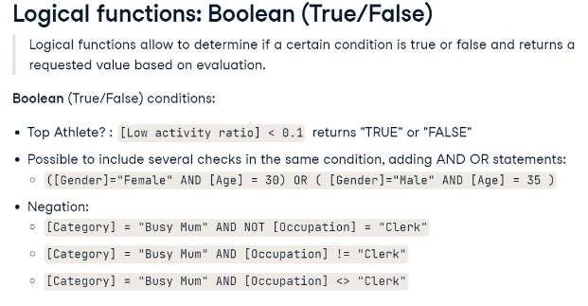

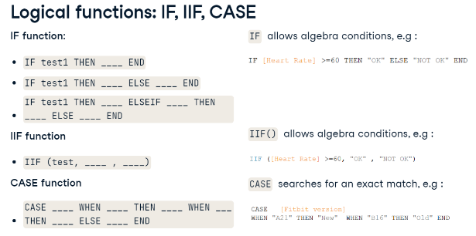.

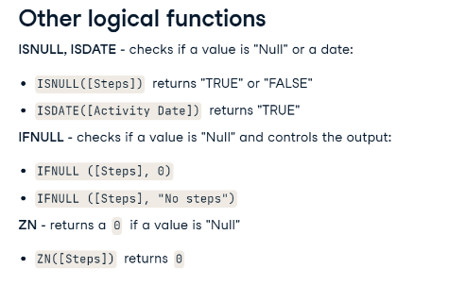

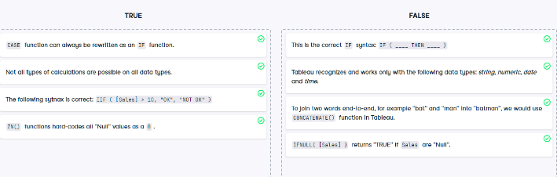

# Text Functions

* Transform – Split
* Alias 1 and 0

# Granularity

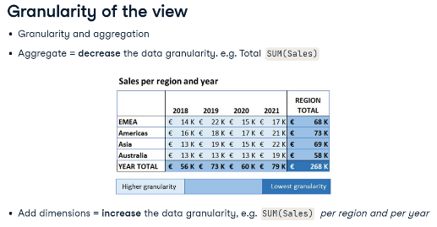

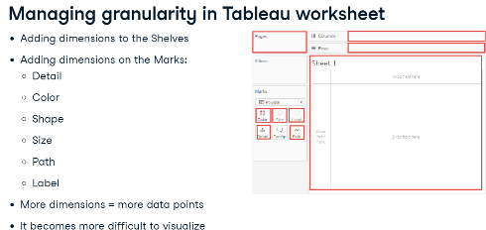

# LOD Expressions (Level of Detail)

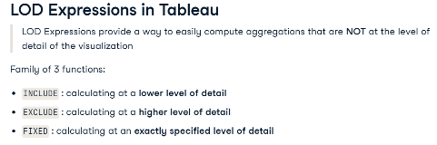

# FIXED LOD Expression

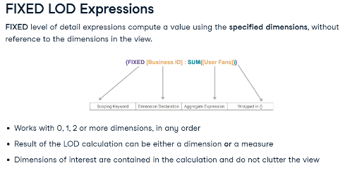

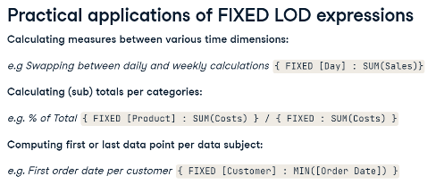

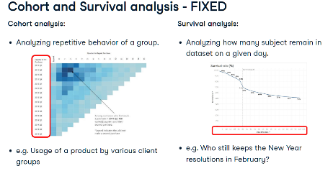

# INCLUDE LOD Expression

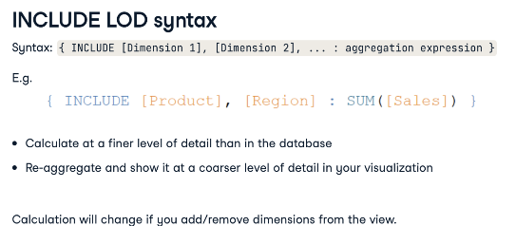

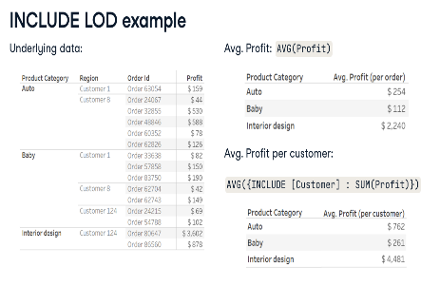

# EXCLUDE LOD Expression

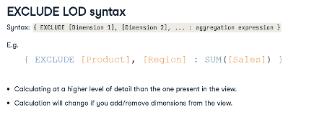

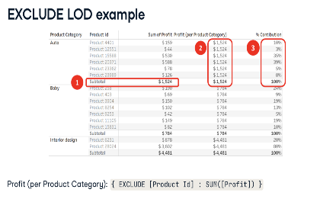

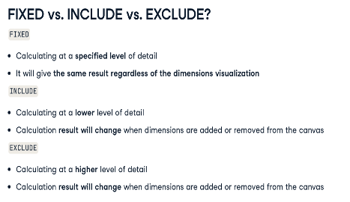

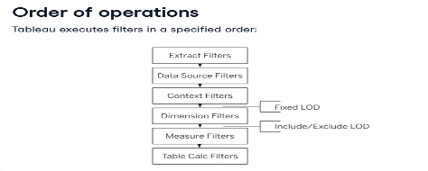

# Table Calculations

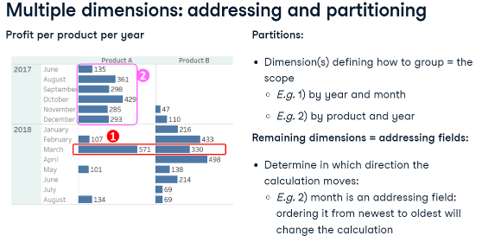

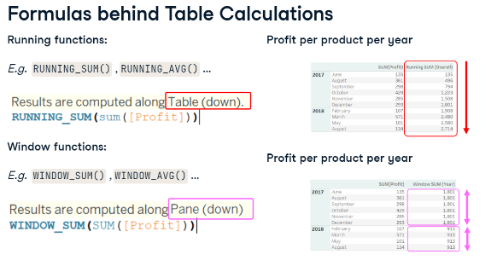

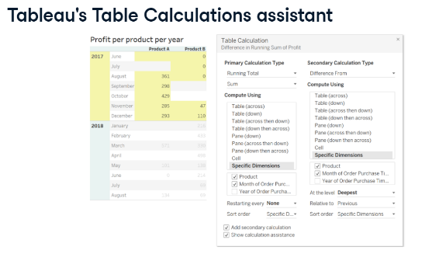

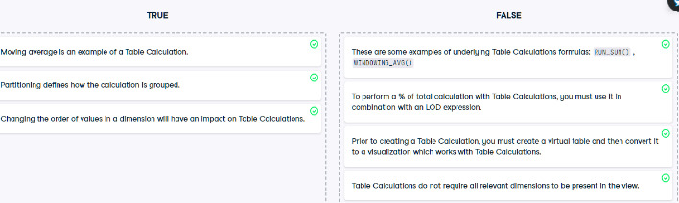

* Ranking default – Table across
* If desired Ranking dimension in Columns – Choose Table Down

# Time Series Analysis

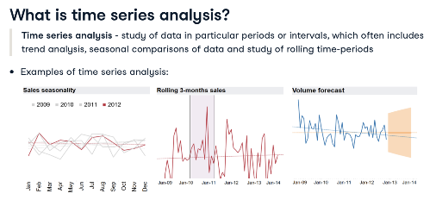

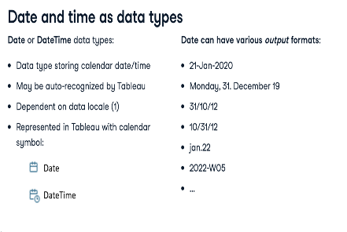

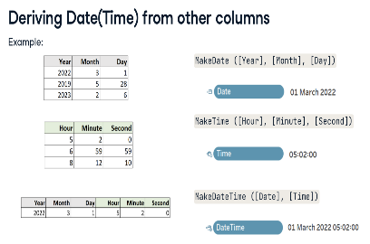

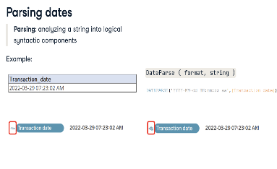

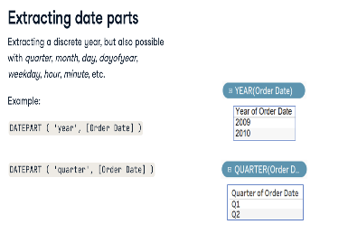

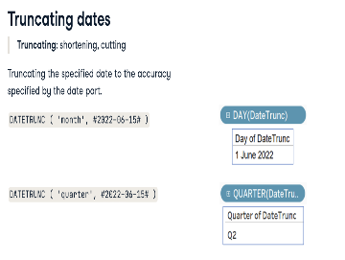

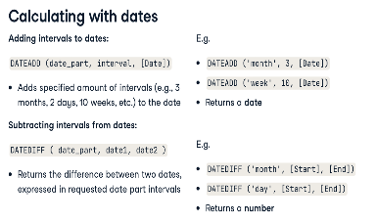

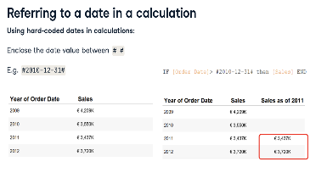

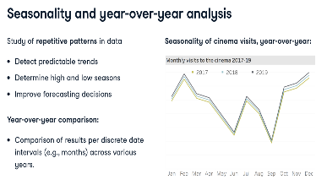

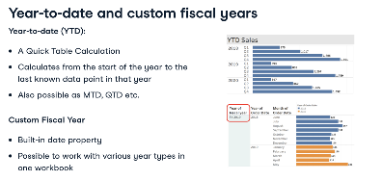

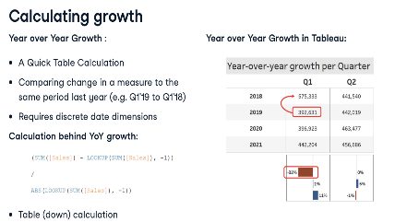

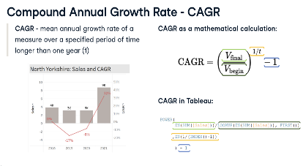

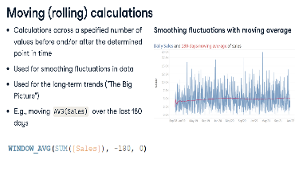

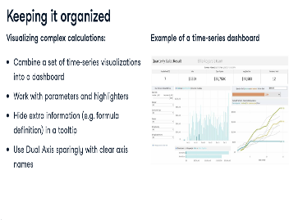

* Calculate Moving Average – Right Click measure in Rows – Quick Table Calculation – Moving Average
* Adapt Moving Average – Double click measure in Rows – Adapt start value (-5 for 5 week average)
* START OF WEEK - DATEDIFF('week',[Order Date],[Return Date], 'sunday')

# Case Study: Job market analysis in Tableau

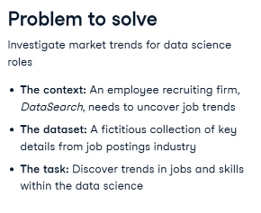

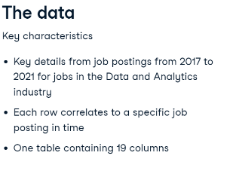

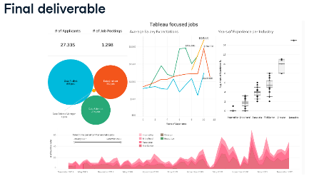

# Exploratory Data Analysis

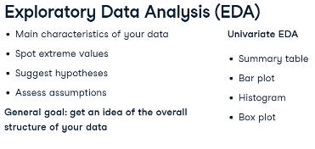

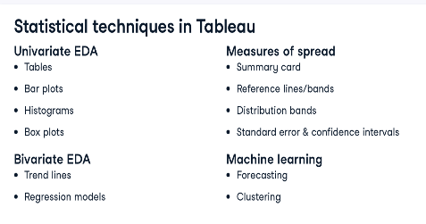

# Statistics

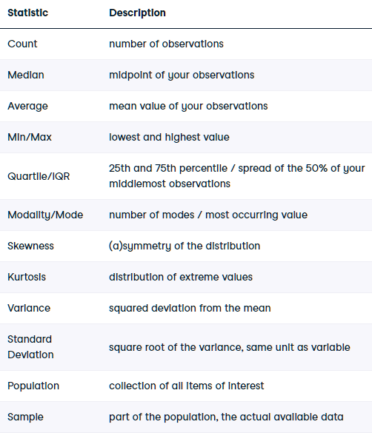

# Tables & Bar plots

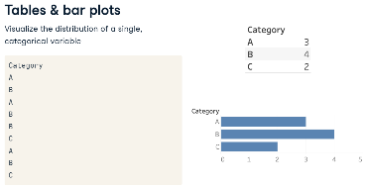

# Histogram

* Compute using Pane across for side-by-side comparison
* Bar plot for a continuous variable
* Set pill bin sizes – Columns (Continuous if large data)
* Set same pill to Count - Rows
* Select pill – Show me - Histogram
* Set Parameter for Bin size

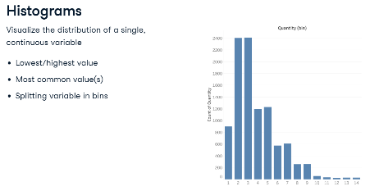

# Box plot

* Standardised chart for distribution of data based on a five-number summary for a Continuous variable
* Spot trends and differences - Compare distributions among multiple categories
* Data distribution, variance, symmetry or skewness, outliers
* Whiskers or Hinges (Tableau) - Minimum, Maximum, Median, First quartile, Third quartile
* Does not show average (mean)
* Disaggregate data - Analysis Menu
* Disaggregate data - Drag to Details Marks
* Sort by different fields

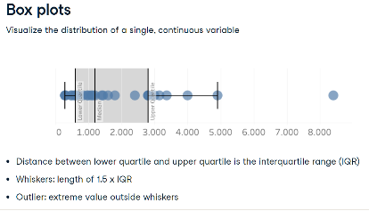

# Skewness

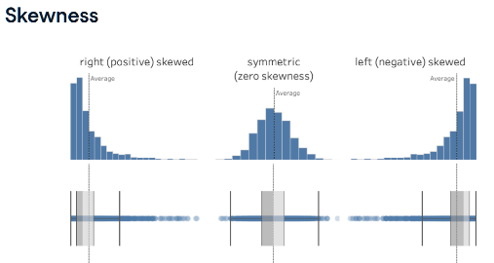

# Kurtosis (Variance)

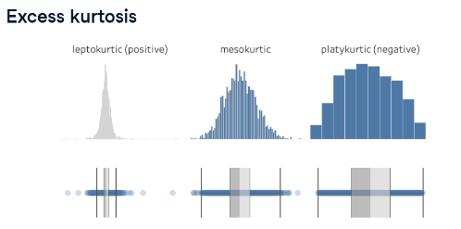

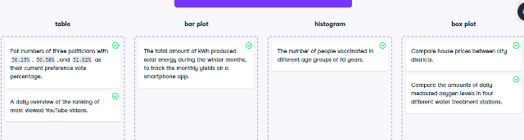

# Spread

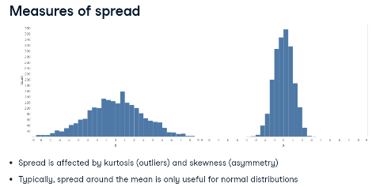

# Variance (Kurtosis)

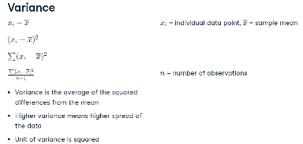

# Standard Deviation

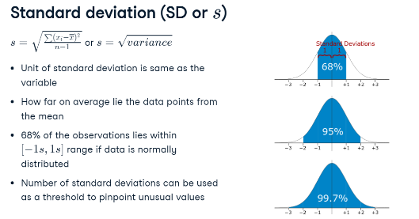

* 68% lies within 2 Sd from mean (1 Sd on each side)– Normal distribution
* Sd is affected by outliers
* Leptokurtic (many outliers) – IQR (50% of data) – Better spread measure (not influenced by outliers)

# Spread – Sample vs Population

* Tableau considers as sample by default
* Difference denominators
* Sample: n-1
* Population: N

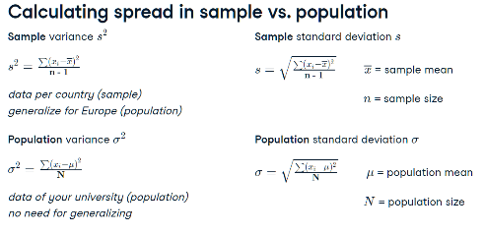

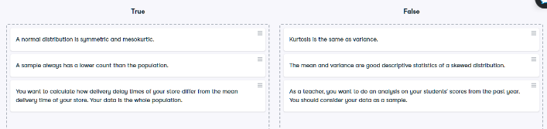

# Standard Error (SE)

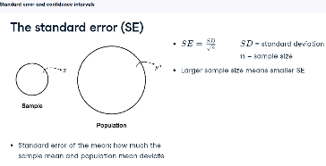

# Confidence Interval (CI)

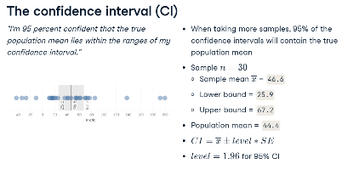

* Sample Mean – Variance – Sd – SE – CI
* Edit All Trend Lines - Show Confidence Band

# Scatter plot

* Relationship between 2 variables
* Variable of interest is placed on Y-axis by convention
* 2 ways to disaggregate your data.
* Drag unique row identifier to Detail mark – then drag pills to the Rows an Column shelves (aggregates points with more then 1 measurement)
* Analysis menu – turn off Aggregate Measures - safest way - each row represented as a single point (does not require a unique identifier - but impossible to exclude data points if leaving out extreme values)

# Correlation

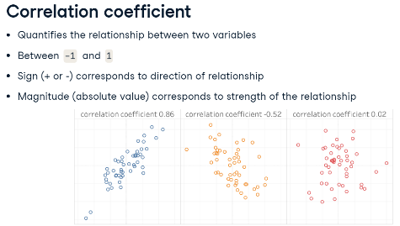

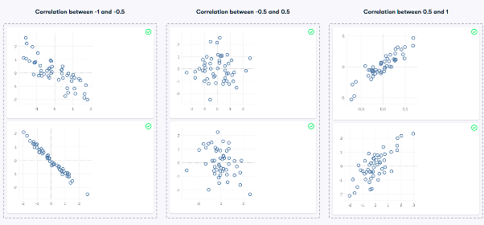

# Trend Lines

* Right click Canvas – Show Trend line
* Analytics Menu – Trend line
* Selecting parts of data points changes Trend line

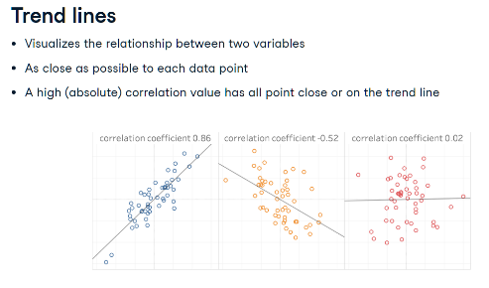

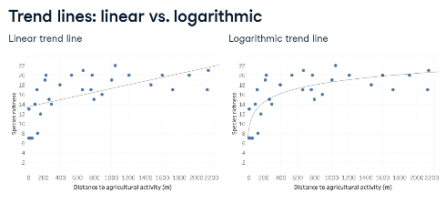

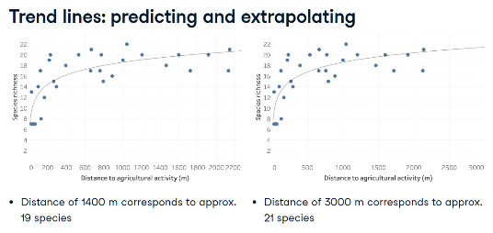

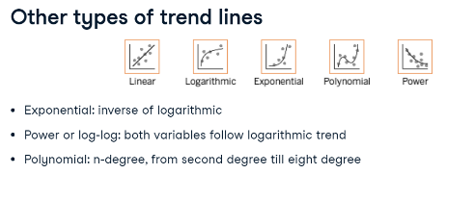

# Assessing Trend Lines

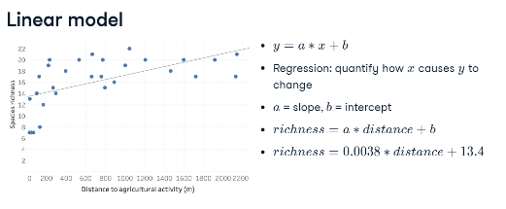

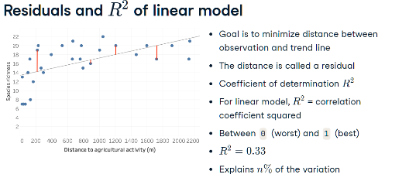

* 33% of variation in richness is explained by the distance – poor fit

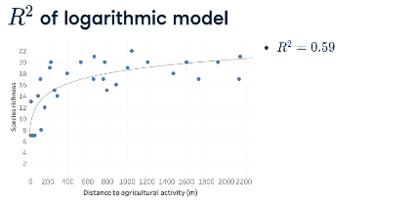

* 59% of variation in richness is explained by the distance – better fit
* Tableau shows R squared as natural log – should be exponentiated

# Residual Standard Error (RSE)

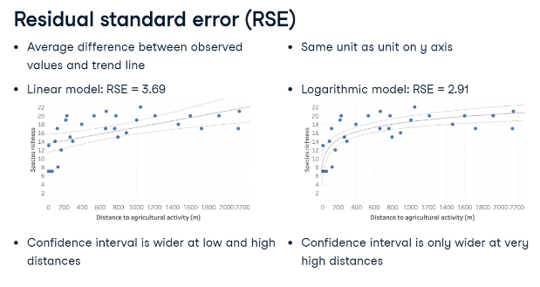

* Linear Model RSE 3.69 - differs 3 – 4 species from the observed value
* Logarithmic Model RSE 2.91 – differs 2 - 3 species from the observed value

# p-value

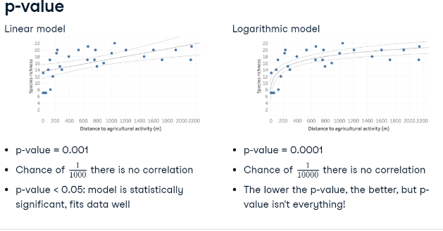

# Forecasting

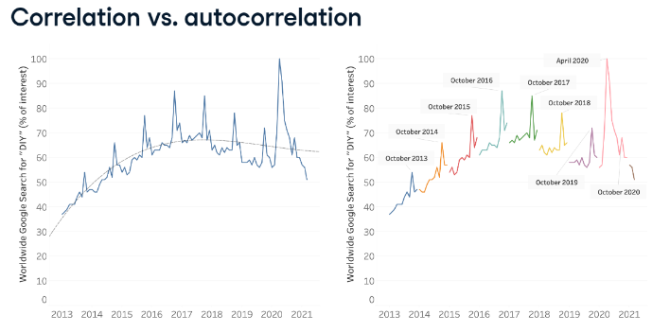

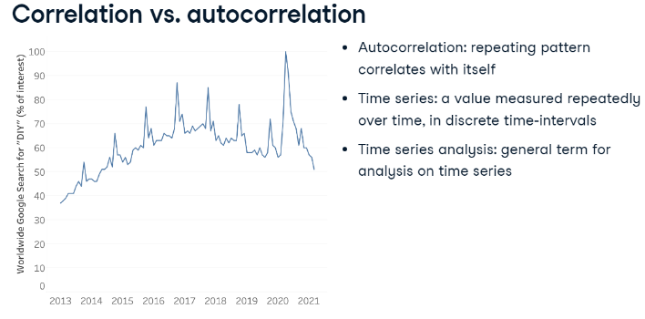

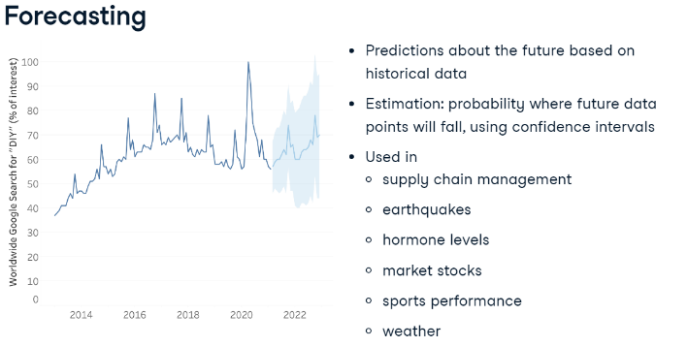

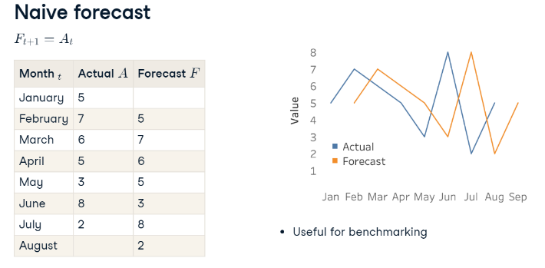

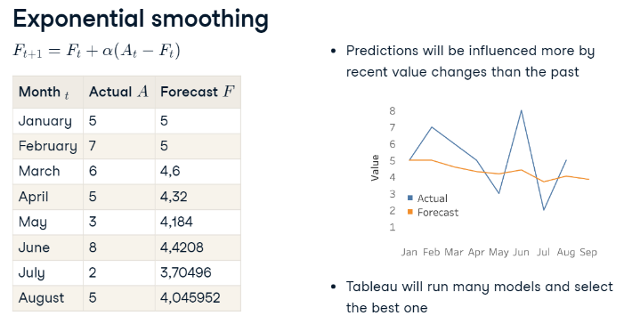

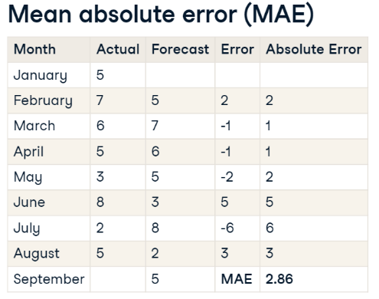

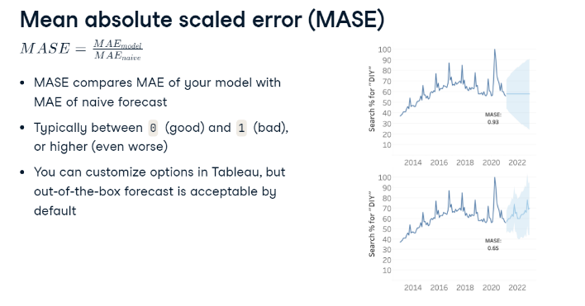

* Change Forecast Indicator to ATTR

# k-means Clustering

* Clustering is an example of unsupervised machine learning.
* E.g. Differentiating between tissue types or segmenting customers in different groups
* Don't know beforehand what tissue types or customer groups are present in the data
* Let the unsupervised algorithm figure out which data points are more similar to each other
* Out is a set of clusters.
* k-means clustering can be applied to one, two, or more variables – k = number of clusters you want
* E.g. k = 3 if you want to split your data into three categories good, medium, and bad
* Also let Tableau suggest number of clusters if k isn't specified
* All distances between the random centres and each data point are measured
* Each data point is assigned to the centre it is the closest to - each centre is then moved to the new centre of the points assigned to it
* The process is iterative: all distances between each data point and the new centre are measured again, and the data points are assigned accordingly
* Once the centre stops moving between iterations, the final clusters are set
* Can’t assess the quality of the clustering result by comparing actual and predicted values
* Two metrics are used to assess the clustering algorithm: between-group sum of squares and within-group sum of squares
* Between-group sum of squares measures the separation between the clusters as the sum of squared distances between each cluster’s centre, and the average value of the data set - The larger the value, the better the separation between clusters
* Within-group sum of squares quantifies the cohesion of clusters as the sum of squared distances between the centre of each cluster and the individual data points in the cluster - The smaller the value, the more cohesive the clusters
* Create Matrix – Drag same values to Rows and Columns – Disaggregate

